Coupon Management System
Submitted To: Anshumat Foundation
Submitted By: Snehal Bhagwate
College: KDK College of Engineering
Project Title: Coupon Management System

Project Overview
This project is a web-based Coupon Management System where admins can create, view, update, and delete discount coupons, best coupons. It also includes authentication using JWT.

Technologies Used
- Node.js
- Express.js
- MongoDB
- JWT Authentication
- Hoppscotch for API testing

Features
Feature | Description
Add Coupon | Create a new discount coupon
View Coupons | Fetch all available coupons
Get by Code | Fetch specific coupon using coupon code
Update Coupon | Edit coupon details
Delete Coupon | Remove coupon using coupon code
Best coupons  Authentication | Best Possible discount  Secure APIs using JWT token

API Endpoints
Method | Endpoint | Description
GET | /api/coupons | Get all coupons
GET | /api/coupons/:code | Get a coupon by coupon code
POST | /api/coupons | Create a new coupon
PUT | /api/coupons/:code | Update a coupon
DELETE | /api/coupons/:code | Delete a coupon

How to Run Project
- Clone project folder
- Install dependencies
- npm install
- Run application
- npm start
- MongoDB connection required
- Use JWT Token for Protected Routes (POST, PUT, DELETE)

Screenshots
- Login (POST)
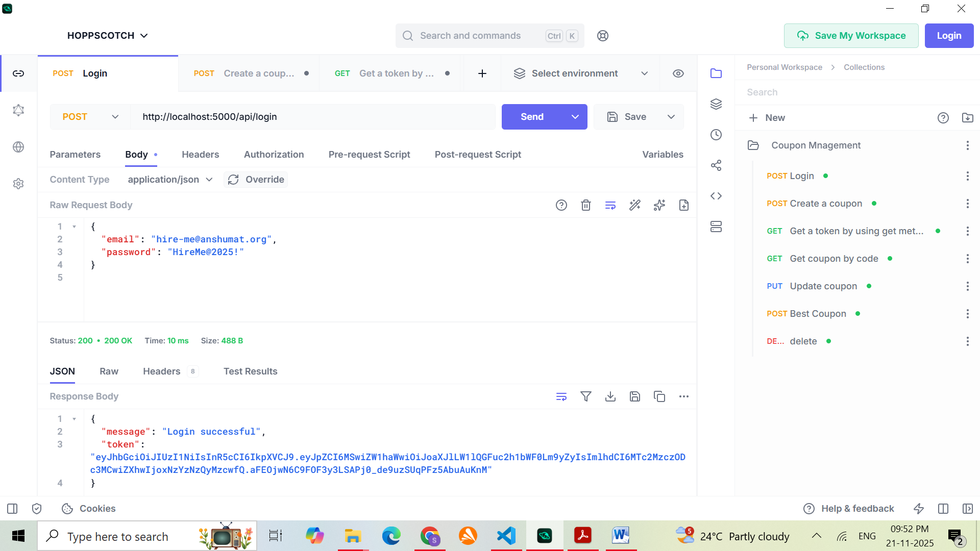
Create Coupon (POST)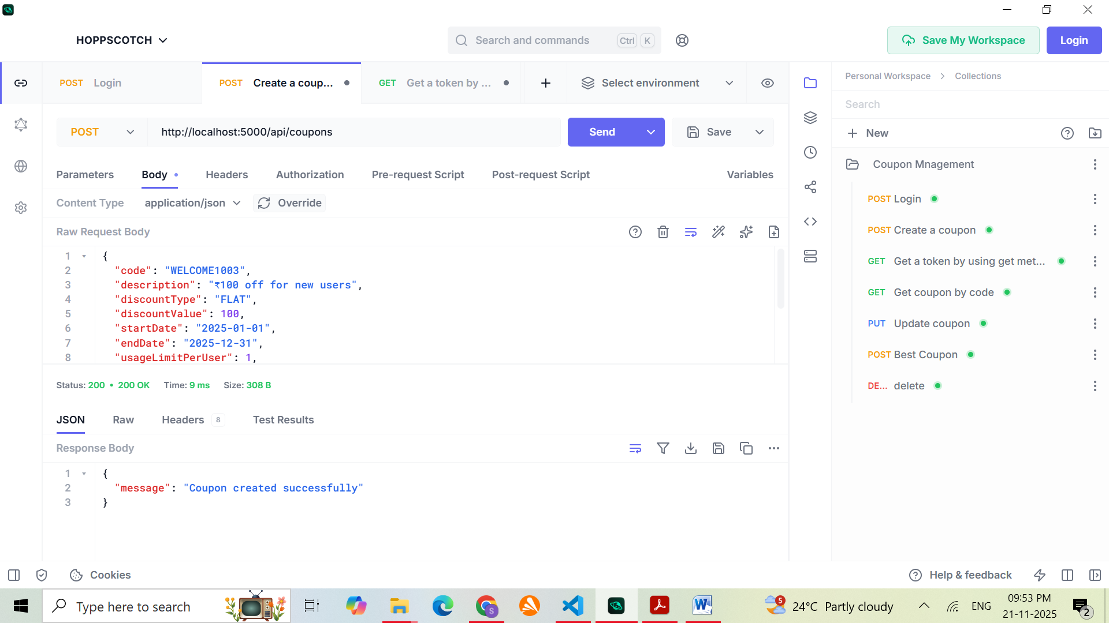
- View All Coupons (GET)
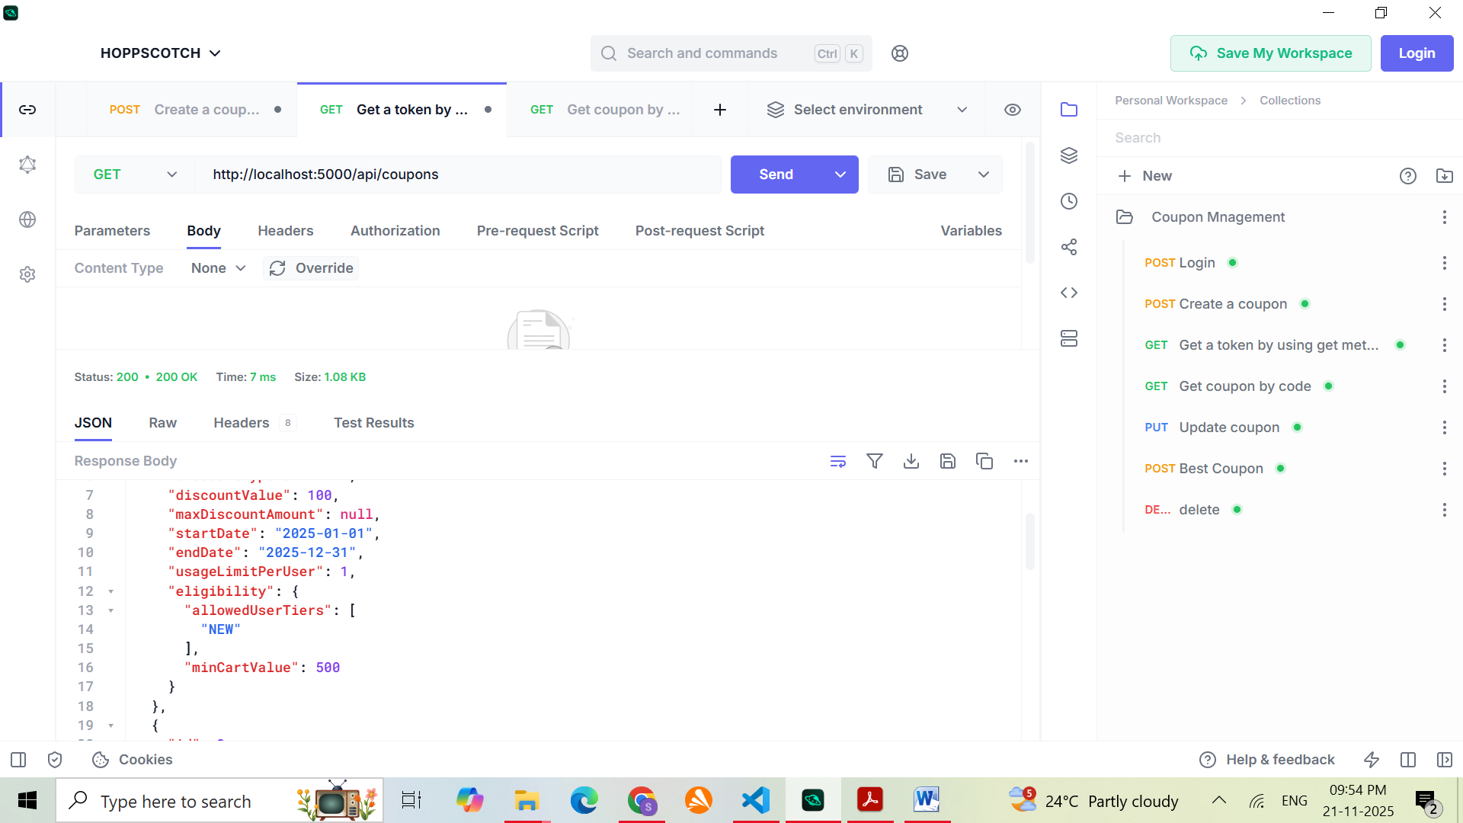
- Get Coupon by Code (GET)
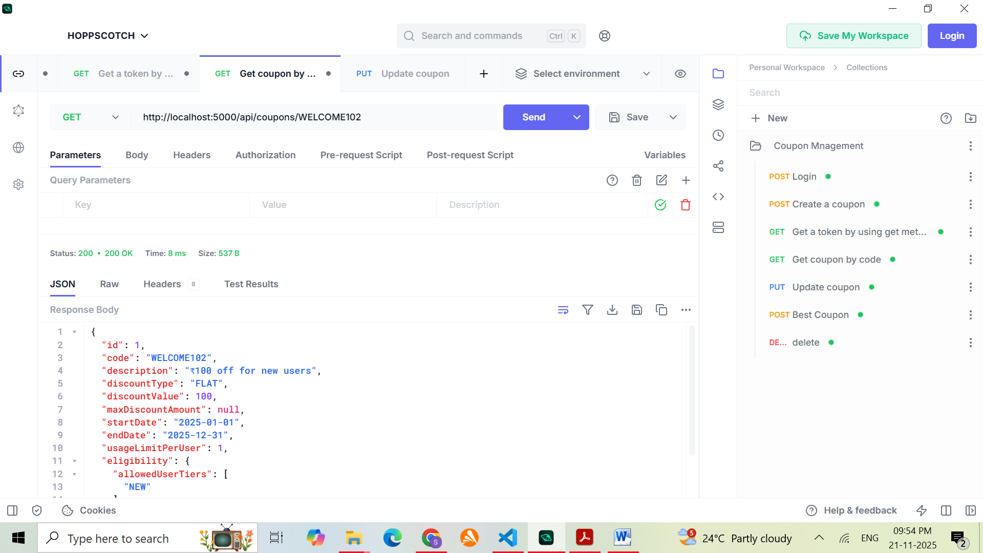
- Update Coupon (PUT)
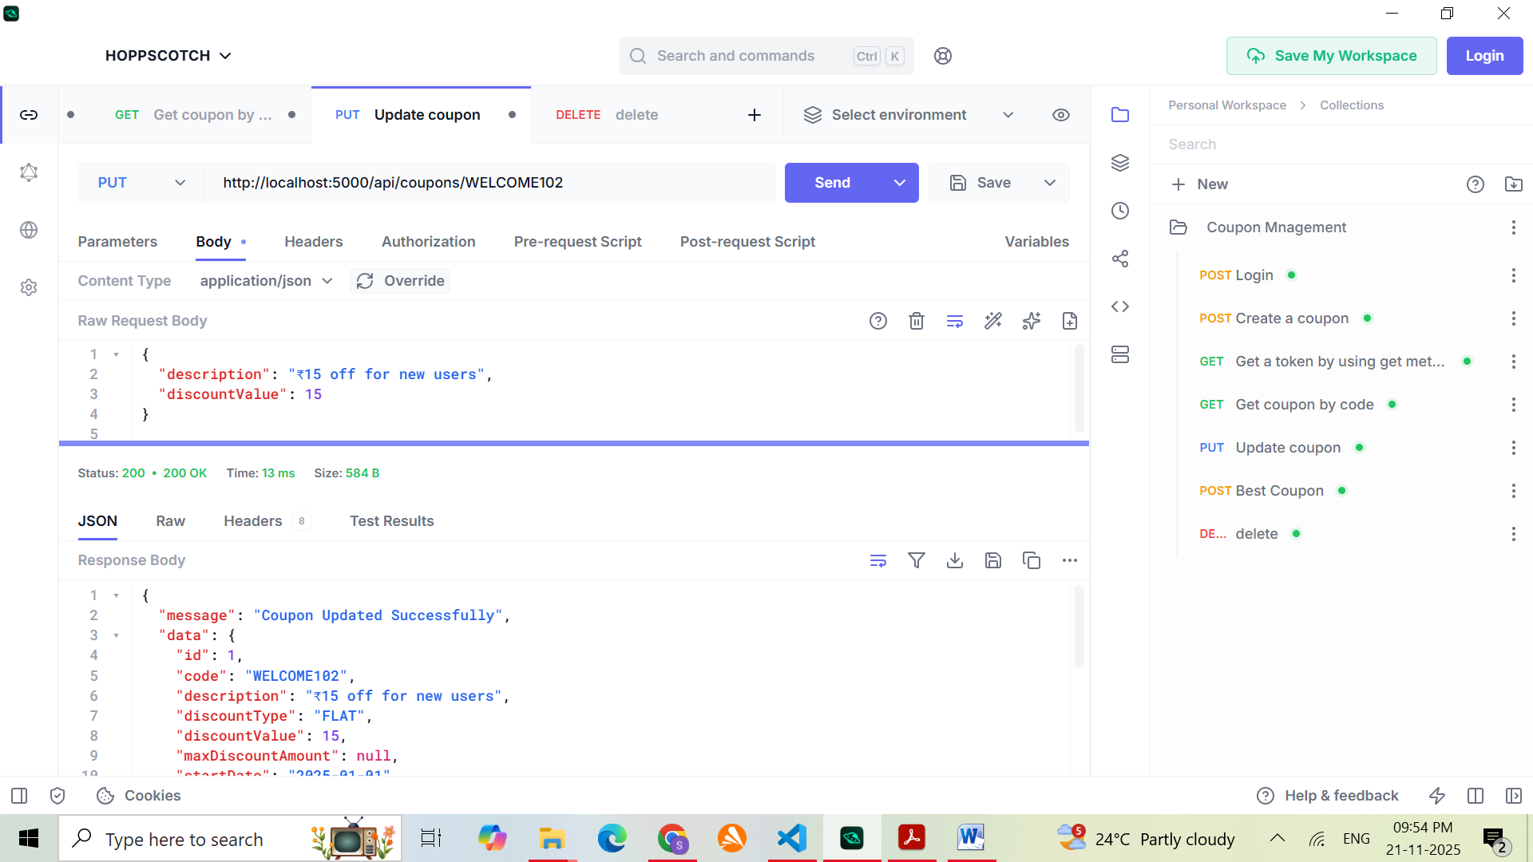
- Delete Coupon (DELETE)
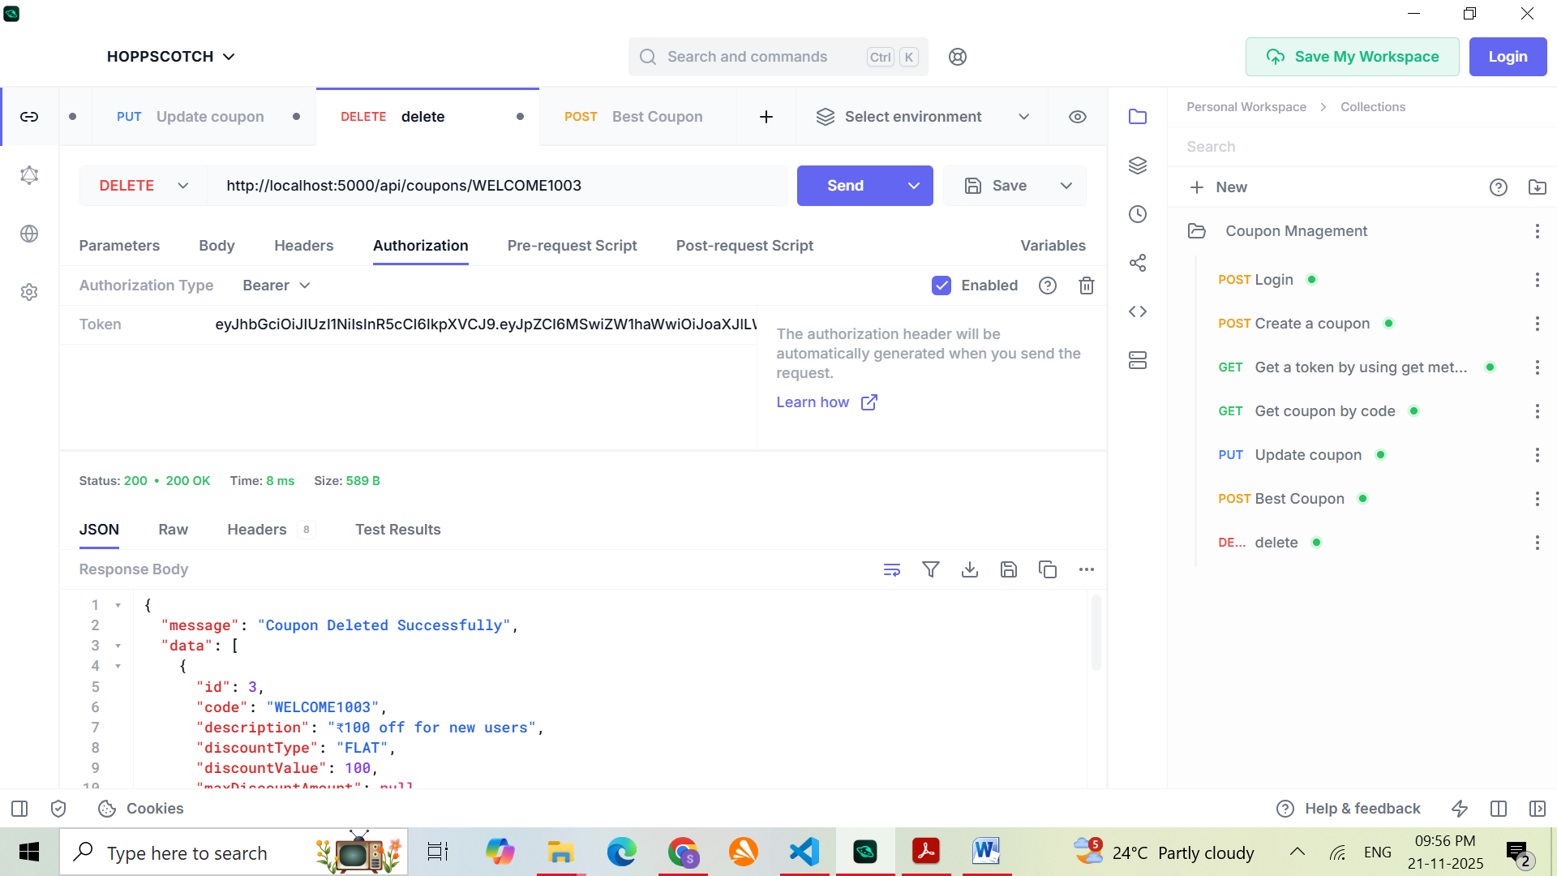
- Best Coupon
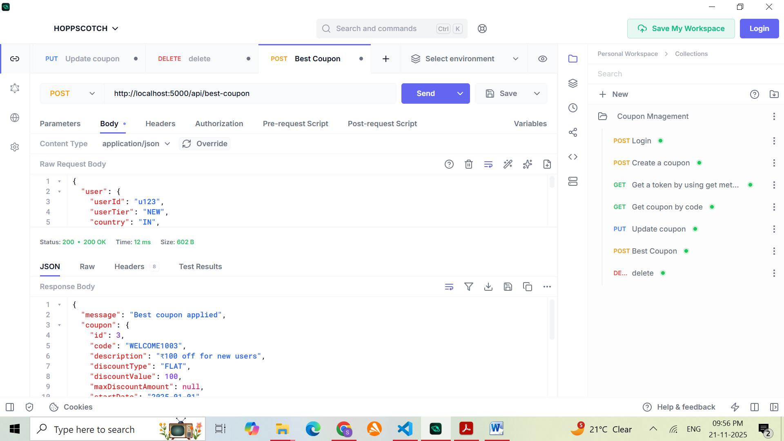

Thank You.

